**Assignment**

**Module-1 *SDLC***

**Name: - Kishan Panara**

**What is software ?**

* Software is a collection of instructions, information & data.

Which helps pc to run.

* It includes the programs, applications & operating systems.

**What is Software engineering?**

* Software engineering is the process of designing, creating, testing, and maintaining software.
* It involves the use of engineering principles and methods to ensure that the software is of high quality, reliable, and easy to maintain.
* This includes the use of programming languages, development tools, and methodologies to design, implement, test, and maintain the software.
* It also includes the management of the software development process and the use of best practices to ensure that the software meets the needs of its users.

**Explain types of software**

*There are several types of software as below:*

* System software: This type of software controls the basic functions of a computer and allows other programs to run on it. Examples include operating systems, device drivers, and firmware.
* Application software: This type of software is designed to perform specific tasks for users. Examples include word processors, web browsers, and games.
* Utility software: This type of software is designed to perform specific tasks to maintain and optimize the performance of a computer. Examples include disk defragmenters, antivirus programs, and backup software.
* Embedded software: This type of software is designed to control specific hardware devices or machines. Examples include firmware for consumer electronics, embedded systems for cars, and software for medical equipment.
* Web-based software: This type of software is designed to run on a web browser and is accessed over the internet. Examples include online email services, social media platforms, and cloud storage services.
* Mobile software: This type of software is designed to run on mobile devices such as smartphones and tablets. Examples include mobile apps for gaming, social media, and productivity.
* Artificial intelligence software: This type of software is designed to mimic human intelligence and perform tasks such as decision-making, problem-solving, and natural language processing.
* **What is SDLC? Explain each phase of SDLC**

The Software Development Life Cycle (SDLC) refers to a methodology With clearly defined processes for creating high-quality software.

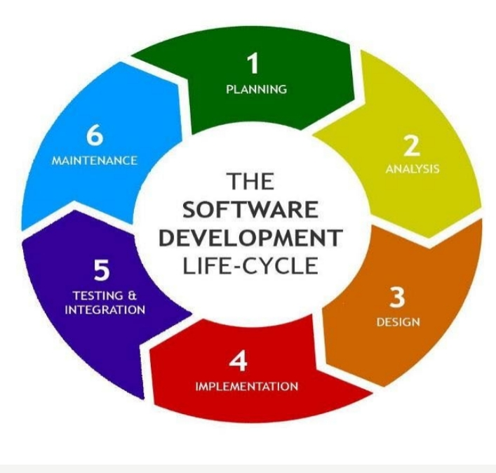Top of Form

* **What is DFD? Create a DFD diagram on Flipkart**

***DFD- Data Flow Diagrams :-***

Graphical representation of flow of data inside application. Used for visualization and data processing.

DFD elements are:

◦External Entity

◦Process

◦Data Flow

◦Data Store

* 1. **External entity:** Can be user or external system that performs some Process or activity in project Symbolized with rectangle.
  2. **Process:** Work or action taken on incoming data to product Output. Each process must have input and output
  3. **Data Flow:** Can be used to show input and output of data Should be named uniquely and don’t include word ‘data’ Names can be ‘payment’, ‘order’, ’complaint’ etc.
  4. **Data Store:** Can be used to show database tables Only process may connect data stores. There can be two or more process sharing same data store

* **DFD diagram on Online Shopping**

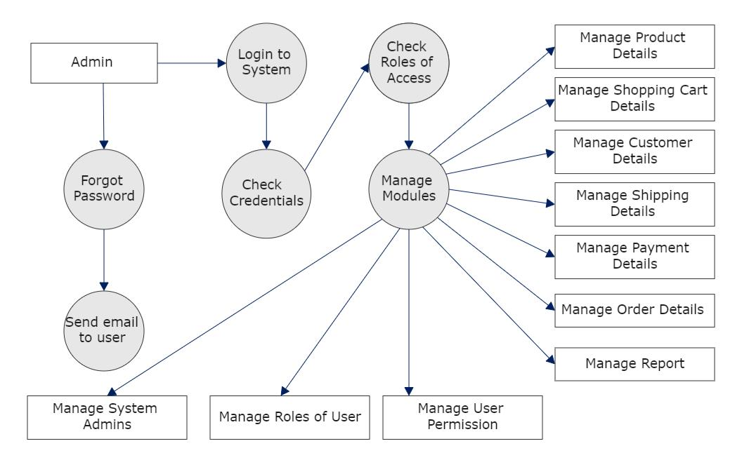

* **What is Flowchart:-**

• Used to show algorithm or process . Can give step solution to the problem

• The first flow chart was made by John Von Newman in 1945

• Pictorial view of process

• Flowcharts are generally drawn in the early stages of formulating computer Solutions.

• Flowcharts facilitate communication between programmers and business people. These flowcharts play a vital role in the programming of a problem and are quite Helpful in understanding the logic of complicated and lengthy problems.

• Once the flowchart is drawn, it becomes easy to write the program in any high level Language.

•Often we see how flowcharts are helpful in explaining the program to others. Hence, it is correct to say that a flowchart is a must for the better documentation of a Complex program.

* + **Flowchart to make addition of two numbers :**

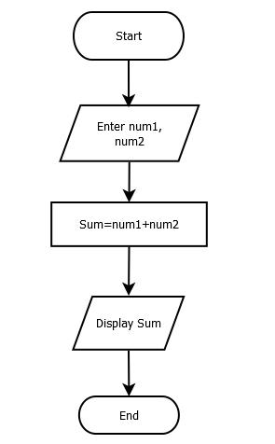

* **What is Use case Diagram? Create a use-case on bill payment on paytm.**

A use case diagram is a graphical depiction of a user’s possible interactions with a system. A use case diagram shows various use cases and different types of users the system has and will often be accompanied by other types of diagrams as well. The use cases are represented by either circles or ellipses.

